**Installation guide for java certificate server**

**Requirements:**

* Java 8 - http://www.oracle.com/technetwork/java/javase/downloads/jdk8-downloads-2133151.html
* NetBeans IDE - https://netbeans.org/downloads/

**Step 1: Install/Use latest NetBeans IDE**

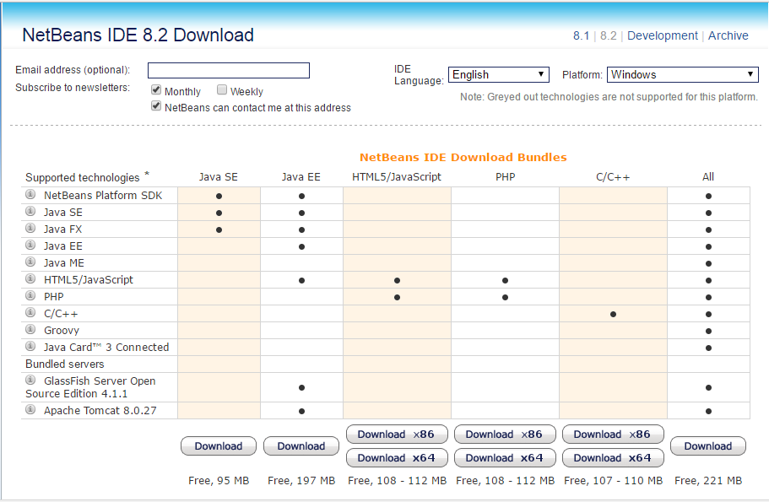

Download NetBeans IDE with Java SE or All. Download link is provided at the requirements section above.

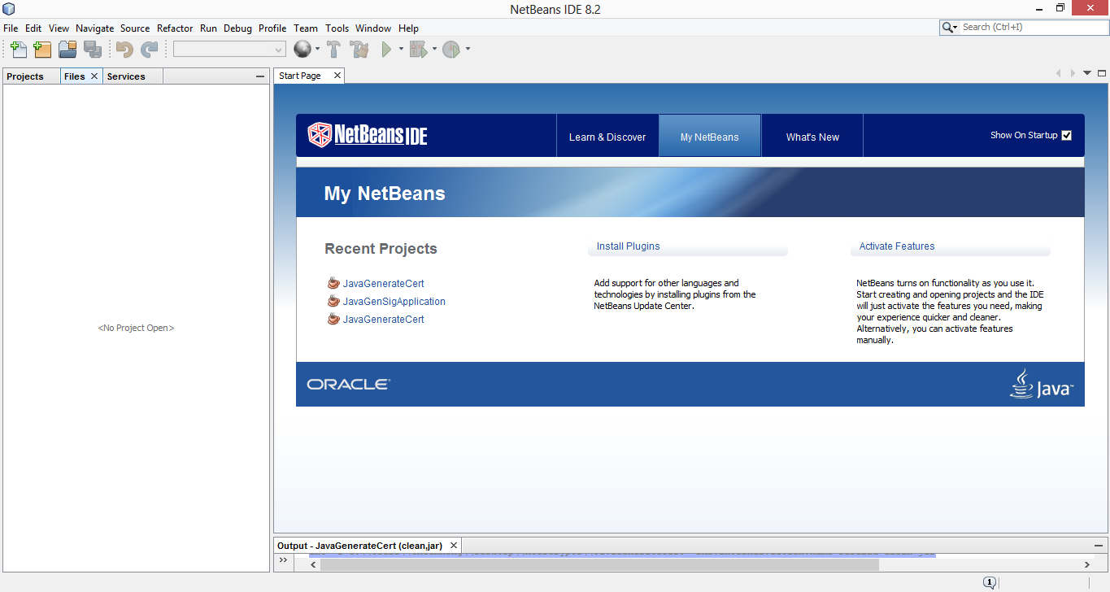

Open the NetBeans IDE 8.2.

**Step 2: Open the project file (JavaGenerateCert)**

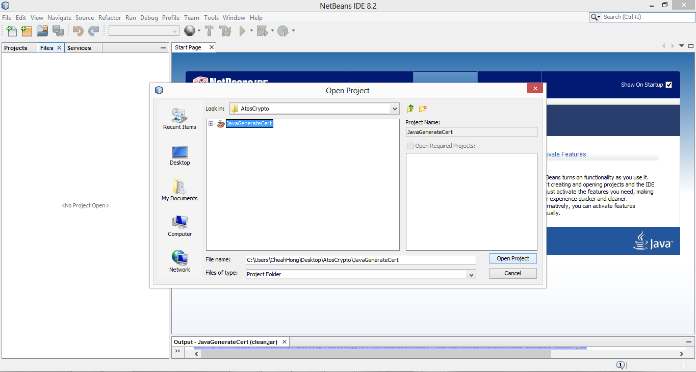

Find the project path and open the project.

**Step 3: Customizing current location**

For demo purposes, currently there are three location folders available in the project file, namely Btu, Kch and Mri (Bintulu, Kuching, Miri ), which are the cities of Sarawak, Malaysia.

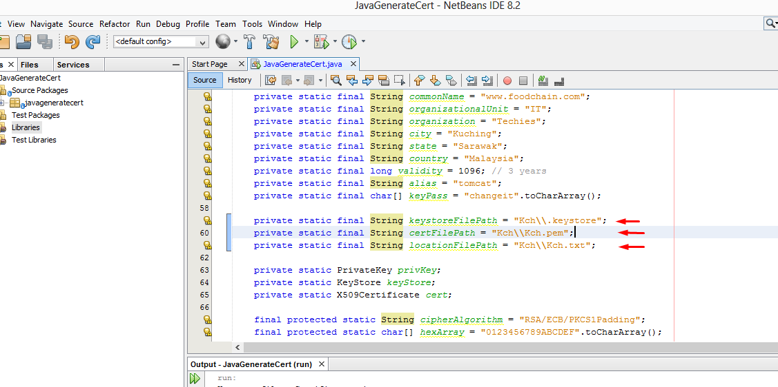

To change between locations, simply go to the JavaGenerateCert.java and change the string paths as shown in the diagram above. For instance, change the word “Kch” to “Btu” or “Mri”.

**Step 4: Run the project**

